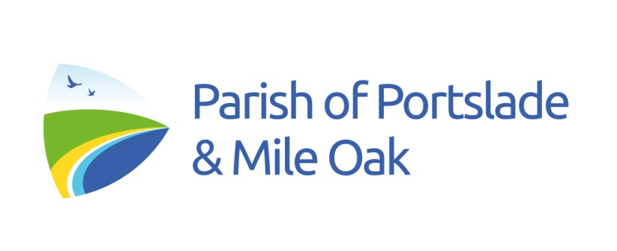
Fr David Swyer SSC (Vicar): 07872 572681: davidswyer64@gmail.com
www.portslade-mileoak.org.uk
18th Sunday in Ordinary Time

New English Hymnal
333 All my hope on God is founded; 377 Immortal, invisible; 336 Angel-voices ever singing;
Communion: 272 All for Jesus! The Angelus is said or sung at the end of mass in St Nicolas (p. 18 of service booklet)

SUN 3 18th Sunday in Ordinary Time
10.00am Joint Parish Mass (St Nicolas) (NB Time change for August)

Tue 5 Feria
10.00 Morning Prayer (S Nicolas)

Wed 6 The Transfiguration of the Lord
10.00 am Morning Prayer (The Good
Shepherd)

SUN 10 19th Sunday in Ordinary Time
10.00am Service of the Word (The Good Shepherd)

Intercessions
PRIEST: As we seek to make the riches of God’s Kingdom our highest priority let us present our prayers and petitions to him:

READER: For Martin, our bishop and all our Church leaders, that they may continue to call the faithful to reject materialism and root their lives in God’s love and mercy.
Lord in your mercy
Hear our prayer

For those in government, that they may do all in their power to protect the rights and dignity of all people.
Lord in your mercy
Hear our prayer

For our own parish community, that we may share our resources and talents in service to the poor and disadvantaged.
Lord in your mercy
Hear our prayer

For all who are sick or housebound, that they will feel Christ’s healing touch in their lives. For…
Lord in your mercy
Hear our prayer

For all who have died, that they may rest in peace and rise in glory. For…
Lord in your mercy
Hear our prayer

In a moment of silence, we offer our own petitions

We join our prayers with those of our Blessed Mother

Hail Mary…

PRIEST: God our Father, you are our strength and joy. Open our hearts to your grace and lead us to your Kingdom. We make this prayer through Christ our Lord.

Please pray for:
The Sick: Irene Harman, Tracey Harman, Barbara Woodward, Janet Edwards, Ryan Woolgar, Christine Smith, Phillip Jones, Tony Johnson, Susan Styles, Adrian, Gordon Cubberley, Beverley Cubberley, Mel, Fr Andrew Perry, Seema, David Greaves, Joyce Wright,

The Departed: Lisa Cannon

Year’s Mind: Norman White 2nd, Edith Shrimpton 7th, Irene Olive May 8th, Bruce White 8th

August
A Joint Parish Mass at 10.00am

3rd August St Nicolas
10th August The Good Shepherd (Service of the Word)
17th August St Nicolas
24th August The Good Shepherd
31st August St Nicolas

